Task Report

Task Description
This lab demands the discovery of help commands in the CLI. We, like spicy hot wings from BDubs, are awesome in the following ways:
1. We explore shell commands that help with other commands (not as confusing as it sounds)
2. We explore manuals, and more concise than manual descriptions of commands
3. We learn how to retrieve a command with a search of what it does.

These will be helpful to any Cybersecurity Engineer in their daily task. CSA's are certainly not expected to know everything. CSA's must know where to look to quickly and efficiently learn or remind themselves what tools are needed and how to properly use them..

whatis Command
Find out what the cat command does, in a concise output

Command Semantics
    - whatis cat this command gives a one line description of the command in question
    - whatis <command>

man Command
Access the manual for the cat command.
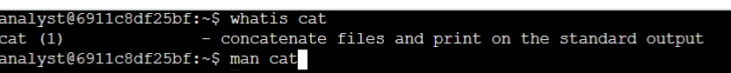
meow : - )
-You can navigate, one line at a time, down the menu by pressing enter.
-Press q to exit the manual page.

Command Semantics
    - man cat dont hit enter unless you want the entire manual for the cat command to be displayed
    - man <command>

apropos Command
Discover a forgotten command using apropos. Consider that you want the first line of a document only. You remember that there is a command that produces this output, but you cannot remember the command. This is the perfect time to use the apropos command

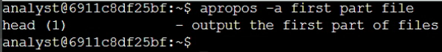

Command Semantics
    - apropos -a first part file this command will search the manual pages for all files containing the words “first”, “part” and “file” in the manual. The output is the command we forgot: head
        - -the -a is necessary when searching for multiple keywords desiring that the AND boolean be used, hence the “-a”, for “and”.
    - apropos <keyword>
    - apropos -a <word1> <word2> *

man Command
This task demands that we add a user with an expiration date. We know that the useradd command is the way to go, but the modifier concerning the expiration date is found to be 404 in our brain.

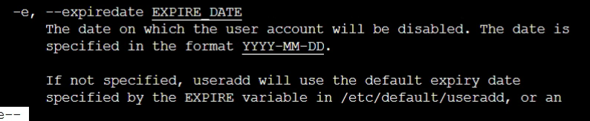
Command Semantics
    - man useradd produces the manual for the useradd command.
        - While discovering the options section of the manual, we uncover the gem we are looking for: the -e modifier

rm & rmdir Commands
These two commands are similar. We are about to begin a workload the requires the use of one or more of these commands, but are unsure of the exact difference. We want to work efficiently, so we ensure we have a proper understanding of these tools before beginning the workload.

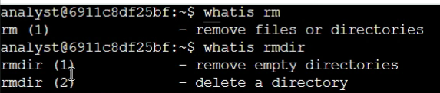

Command Semantics
    - whatis rm outputs a one line description of rm
    - whatis rmdir outputs a one line description of the rmdir command

apropos Command
Another 404 scenario has struck our mind! Good thing the CLI was produced with built-in help commands. We must create a new group, however we cannot remember which command to use. It is the apropos time to use the apropos command. We will have apropos search the manuals for the keywords: create AND new AND group.

Command Semantics
    - apropos -a create new group this command searches the manuals for keywords. The modifier -a indicates to the CLI to use the AND boolean between the words “create” AND “new” AND “group”
        - The result is the command we need to add a group: groupadd

Summary
A day in the life of a forgetful Cybersecurity Engineer, but at least he likes hot wings right! We find the man, whatis and apropos commands to be useful for
    - whatis – quickly tells us what the cat command is used for
    - man – displays the full manual of the cat command
    - apropos – to help us find which command displays only the head of a file
    - man – used again to find the modifier needed to go along with useradd command to put an expiration date on a new user
    - whatis – used once more to differentiate between the two similar commands rm and rmdir
    - apropos – lastly we use apropos once again to remind us how to add a group to our organization.

Thanks to the built-in help commands of the CLI, we are able to ensure our company's security remains hardened by completing the various Cybersecurity tasks that are needed to be completed.

